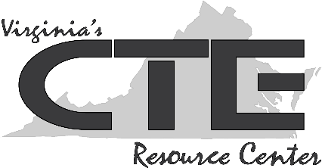
Teacher Resource #2: Questions to Ask a Prospective Employer

What is the company’s practice regarding the training and professional development of its employees?

Where do you see the company in five years, and how would the person in this role contribute to this vision?

What is your company’s view on work-life balance?

How would you describe the work environment? Is it fast-paced? Formal? Competitive? Collaborative?

What opportunities exist for employee growth within the company?

Beyond the hard skills, what do you think are the most important qualities for someone to excel in this role?

How would you describe the culture of the company?

What do you like best about working for this company?

How would you score the company on living up to its core values? What's the one thing you're working to improve?

