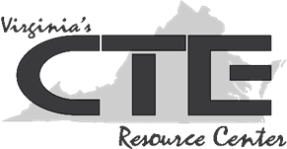
Handout #2:
Interview Guidelines

Before the Interview
Remember, first impressions are important. | Be punctual.
Research the company; be sure you know the interviewer’s name. | Be neat and clean. Make sure teeth are freshly brushed. Do not wear heavy cologne or perfume.
Review directions to the interview location beforehand; consider parking and other logistical concerns. | Dress professionally. Avoid loud colors and opt for classic styles over trends. Hair should be neatly styled.

During the Interview
Use good posture. | Establish eye contact.
Smile. | Give a firm handshake.
Use the interviewer’s last name (Ms. Cordoza, Mr. Jacobs, Dr. Rose). | Be honest and sincere.
Be positive; never speak negatively about a previous employer (or anyone else for that matter). | Elaborate—don’t simply say “yes” or “no.”
Be succinct; don’t share long-winded scenarios or stories. | Take a moment to think about your answers before responding.
Ask questions to clarify information, such as duties, hours, future assignments, possibilities for advancement, and procedures. | Ask when a decision will be made and what the procedures are for notifying applicants.
Finish on a positive note with a thank-you and a handshake.

After the Interview
Follow up with a thank-you note, either mailed or emailed to the interviewer(s). Have someone you trust proofread your note before you send it. | If you haven’t heard anything in the amount of time the company representative indicated, it is alright to contact the company representative by phone to check on the status of the job posting.

