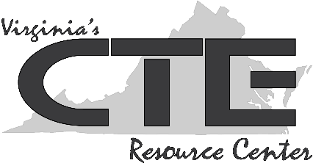
Teacher Resource #1: Workplace Profiles

Profile #1: AUTO PARTS DISTRIBUTOR

Corporate statement: It is the mission of our company to provide personal vehicle owners and enthusiasts with vehicle-related products and knowledge.

Additional Company Information: People at this company tend to remain in jobs for a long period of time; there is low turnover. Because of this, the diversity of the company does not reflect that of its community, which is changing rapidly. The company makes it a priority to invest in employee professional development; loyalty is expected in return. Policies related to things such as work hours and dress codes are traditional.

Profile #2: ONLINE NETWORKING COMPANY

Corporate statement: We give everyone the power to build communities around their own interests.

Additional Company Information: This up-and-coming company has a young and diverse demographic. Workers are fiercely committed to the company’s mission and values, and it shows in the work ethics demonstrated. It is not unusual for workers here to log 80-hour workweeks. Employees work hard, but they are rewarded in many tangible and intangible ways. The culture is casual yet competitive, and the hours, although long, are flexible.

Profile #3: FINANCE GIANT
Corporate statement: Our goal is to be the most esteemed financial services firm in the world.

Additional Company Information: This well-established company has many lifelong employees. However, due to shifts in the marketplace and in the importance of new technologies, there is a recent upsurge in younger workers. This is beginning to change and challenge some traditional company practices. Leadership is grappling with swift market changes. This is a company in transition that prides itself on professionalism and being respected above all else.

Profile #4: AGRIBUSINESS

Corporate statements: We are a company of people who produce food, seek truth, and demonstrate integrity.

Additional Company Information: This agribusiness is involved in a variety of food production. The company highly values workers with impeccable integrity. The company welcomes constructive criticism and offers employees a variety of ways to suggest changes and best practices. Company leadership does not believe in “top-down” change. Rather, they rely on their employees, customers, and other stakeholders to help them define future goals and initiatives. Company leadership prioritizes work-life balance for all employees.

