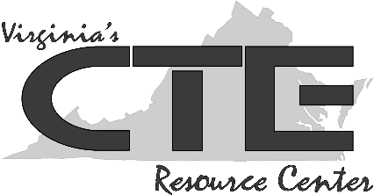
Information Technology Skills:

Managing Files and Folders Handout #1

Use the student-research resource, Electronic File Organization Tips, found at https://www.nist.gov/sites/default/files/documents/pml/wmd/labmetrology/ElectronicFileOrganizationTips-2016-03.pdf to complete the following graphic organizer. Feel free to highlight important points as you read them.

File Naming: Things to Avoid
File Naming: Things to Doo
Electronic Folder Structure: Strategies
Terms and Definitions to Know
Electronic File Organization: Strategies to Remember

